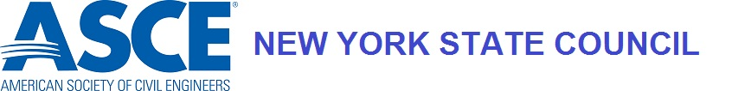

OUTSTANDING CIVIL ENGINEER IN GOVERNMENT

Civil Engineers in government service within New York State are recognized annually by selection of an “Outstanding Civil Engineer in Government”.

This annual award is to acknowledge the engineering efforts of government service Civil Engineers who further the advancement of the practice and profession of civil engineering.

The basis of the award is outstanding engineering achievement accomplished by a civil engineer in government service within the calendar year ending December 31st. Consideration shall be given to the Engineer that has exhibited professional achievement and has made significant impact to the field of civil engineering. This impact may be through professional activities, ASCE involvement, research, and innovative engineering solutions.

This award is intended to be awarded to an individual employed by government organizations.

Nominations for the annual award are made by the Sections that make up the New York State Council. The nominee for this award shall be a Registered Professional Engineer, a member of good standing in one of the Sections that make up the New York State Council, and a resident of New York State. Sections should coordinate with their Branches, organizational entities, and general membership and submit one nominee to the Awards Committee.

Judging will be by the New York State Council Awards Committee.

The award is made by action of the New York State Council at its spring meeting upon recommendation of the Awards Committee. Any recommendation to the Council must be supported by a majority vote of the Awards Committee. Publicity on the final selection is withheld until Council approval is obtained.

The award will consist of a plaque and will be presented at a regular meeting of the local ASCE Section where the awardee is a member. The local Section shall coordinate with the participant regarding attendance at the meeting.

Only one person may receive the award; however, the Awards Committee may present Honorable Mention awards.

Nominations must be submitted to the Awards Committee by March 12th for the previous year ending December 31st. Each nomination must be accompanied by a letter of transmittal and the application form describing how the nominee meets the criteria described above. Supporting documentation should include a digital photograph suitable for publicity purposes.

Submit Nomination to: Awards Committee
New York State ASCE Council
pres.ascenycouncil@gmail.com

